**“Experiment 3.3”**

Student Name: **SUMIT KUMAR** UID: **20BCS8226**

Branch: **CSE** Section/Group: **808-A**

Semester: **5** Date of Submission: **12-11-22**

Subject Name: **Design and Analysis of Algorithms Lab** Subject Code: **20CSP-312**

# Aim:

Code and analyze to find all occurrences of a pattern p in a given string s.

# Task to be done:

To implement Knuth-Morris Pratt algorithm.

1. **Algorithm:**

Unlike Naive algorithm, where we slide the pattern by one and compare all characters at each shift, we use a value from lps[] to decide the next characters to be matched. The idea is to not match a character that we know will anyway match.

How to use lps[] to decide next positions (or to know a number of characters to be skipped)?

* 1. We start comparison of pat[j] with j = 0 with characters of current window of text.
  2. We keep matching characters txt[i] and pat[j] and keep incrementing i and j while pat[j] and txt[i] keep matching.
  3. When we see a mismatch
  4. We know that characters pat[0..j-1] match with txt[i-j…i-1] (Note that j starts with 0 and increment it only when there is a match).
  5. We also know (from above definition) that lps[j-1] is count of characters of pat[0…j-1] that are both proper prefix and suffix.
  6. From above two points, we can conclude that we do not need to match these lps[j-1] characters with txt[i-j…i-1] because we know that these characters will anyway match. Let us consider above example to understand this.

# Code:

#include <bits/stdc++.h>

void computeLPSArray(char* pat, int M, int* lps);

// Prints occurrences of txt[] in pat[] void KMPSearch(char* pat, char* txt)

{

int M = strlen(pat); int N = strlen(txt);

// create lps[] that will hold the longest prefix suffix

// values for pattern int lps[M];

// Preprocess the pattern (calculate lps[] array) computeLPSArray(pat, M, lps);

int i = 0; // index for txt[]

int j = 0; // index for pat[] while ((N - i) >= (M - j)) {

if (pat[j] == txt[i]) { j++;

i++;

}

if (j == M) {

printf("Found pattern at index %d ", i - j); j = lps[j - 1];

}

// mismatch after j matches else if (i < N && pat[j] != txt[i]) {

// Do not match lps[0..lps[j-1]] characters,

// they will match anyway if (j != 0)

j = lps[j - 1]; else

i = i + 1;

}

}

}

// Fills lps[] for given pattern pat[0..M-1]

void computeLPSArray(char* pat, int M, int* lps)

{

// length of the previous longest prefix suffix

int len = 0;

lps[0] = 0; // lps[0] is always 0

// the loop calculates lps[i] for i = 1 to M-1 int i = 1;

while (i < M) {

if (pat[i] == pat[len]) { len++;

lps[i] = len; i++;

}

else // (pat[i] != pat[len])

{

// This is tricky. Consider the example.

// AAACAAAA and i = 7. The idea is similar

// to search step. if (len != 0) {

len = lps[len - 1];

// Also, note that we do not increment

// i here

}

else // if (len == 0)

{

lps[i] = 0; i++;

}

}

}

}

// Driver program to test above function int main()

{

char txt[] = "ABABDABACDABABCABAB";

char pat[] = "ABABCABAB"; KMPSearch(pat, txt); return 0;

}

# Complexity Analysis:

Time Complexity: O(n)

# Result:

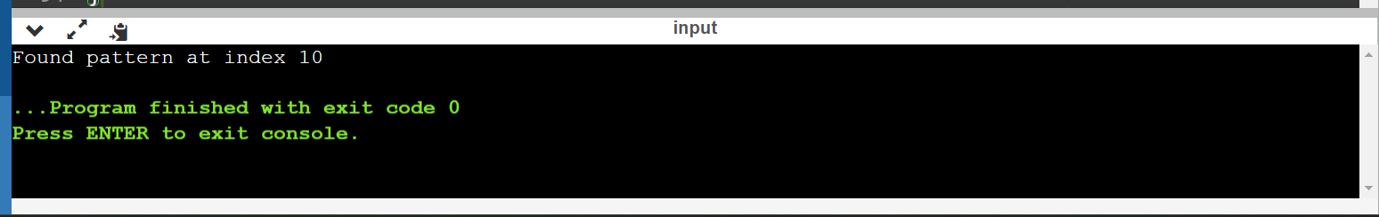

**Learning outcomes (What I have learnt):**

1. Learn about finding pattern in a string.
2. Learn about time complexity of program.
3. Learnt to implement Knuth-Morris Pratt algorithm.

**Evaluation Grid (To be created per the faculty's SOP and Assessment guidelines):**

|  |  |  |  |
| --- | --- | --- | --- |
| Sr. No. | Parameters | Marks Obtained | Maximum Marks |
| 1. | Worksheet completion including writing learning objectives/Outcomes.  (To be submitted at the end of the day). |  |  |
| 2. | Post-Lab Quiz Result. |  |  |
| 3. | Student Engagement in  Simulation/Demonstration/Performance and Controls/Pre-Lab Questions. |  |  |
|  | Signature of Faculty (with Date): | Total Marks Obtained: |  |